***WEB- SYSTEM FOR SELLING ARTISTIC PAINTINGS FOR PEOPLE WITH SPECIAL NEEDS***



**WEB PROJECT (2)**

**FWD291**

**Full Stack Web Developer**

**Supervisor:** Dr. RAHMAH Ali Mohammad BRNAWY

**Presented by:**

**Wafaa AI-Enezi**

**SID #4452720**

**Al-Anoud AI-Rashidi**

**SID #**4451790

**Raneem AI-Juhani**

**SID #4453521**

**Rima Sultan.**

**SID #4452417**

**Reem Al-Harbi**

**SID #4452011**

**Academic Year 1446 AH**

# Acknowledgement

The success and results of this project have required a tremendous amount of guidance, and fortunately we have achieved that throughout our project.

All that we did was, firstly, by the grace of Allah Almighty for His bounty to complete the project, without his blessings, we would not be able to do anything.

Then, we like to express our special thanks and gratitude to our supervisor, **Dr. Hala Hameed**, who helped us and directed us throughout the period of work on this project then.

In the end, the support and help from people around us we think it is necessary to thank them, we thank our professors and colleagues who have been supportive of us throughout the project.

# Abstract

We recognized the need for a platform to empower individuals with disabilities and support their artistic talents. Through developing this web-based system, our team aims to address the socio-economic challenges faced by people with special needs in expressing their creativity and gaining meaningful employment.

Our system provides an inclusive and accessible digital marketplace specifically designed for artists with diverse abilities to display market and sell their paintings.

By leveraging modern web technologies, our solution aims to promote cultural enrichment, empowerment and social inclusion for users. This project represents our effort to utilize technical skills learned in our academic program to positively impact the community. We hope that our system serves as a step towards greater accessibility, opportunities and recognition for disabled artists.

# List of Tables

Table ‎4.4‑1 User Database Table 27

Table ‎4.4‑2 Account Database Table 27

Table ‎4.4‑3 Admin Database Table 28

Table ‎4.4‑4 Artwork Database Table 28

Table ‎4.4‑5 Line Artwork Database Table 29

Table ‎4.4‑6 Order Database Table 29

Table ‎4.4‑7 Payment Database Table 30

Table ‎4.4‑8 Shipping information Table 30

Table ‎4.4‑9 Review Database Table 31

Table ‎4.4‑10 Category Database Table 31

Table ‎4.4‑11 Disability Database Table 31

**List of Figures And Tables**

Figure ‎1.5‑1 Project Timeline 3

Figure ‎2.3‑11 Creative Growth. 7

Figure ‎2.3‑2 2 Saarhi art 8

Figure ‎3.3‑1 Use Case Diagram 15

Figure ‎3.3‑2 use case diagram 2 16

Figure ‎3.3‑3 Flow Chart 1 17

Figure ‎3.3‑4 Flow Chart 2 17

Figure ‎3.3‑5 Flow Chart 3 18

Figure ‎3.3‑6 Flow Chart 4 19

Figure ‎3.3‑7 Flow Chart 5 20

Figure ‎3.4‑1 Waterfall Methodology 21

Table 2 Compare Methodologies 22

Figure ‎4.3‑1 Class Diagram 23

Figure ‎4.3‑2 Sequence Diagram 1 24

Figure ‎4.3‑3 Sequence Diagram 2 25

Figure ‎4.3‑4 Sequence Diagram 3 25

Figure ‎4.3‑5 Activity Diagram 1: Artist Activities 26

Figure ‎4.3‑6 Activity Diagram 2: Buyer and System Activities 26

Table ‎4.4‑1 User Database Table 27

Table ‎4.4‑2 Account Database Table 27

Table ‎4.4‑3 Admin Database Table 28

Table ‎4.4‑4 Artwork Database Table 28

Table ‎4.4‑5 Line Artwork Database Table 29

Table ‎4.4‑6 Order Database Table 29

Table ‎4.4‑7 Payment Database Table 30

Table ‎4.4‑8 Shipping information Table 30

Table ‎4.4‑9 Review Database Table 31

Table ‎4.4‑10 Category Database Table 31

Table ‎4.4‑11 Disability Database Table 31

Figure ‎4.4‑1 Entity-relationship diagrams (ERDs) 31

# Table of Content

Table of Contents

Acknowledgement iii

Abstract iv

List of Tables v

List of Figures And Tables vi

Table of Content viii

1 Chapter 1: Introduction 1

1.1 Introduction 1

1.2 Problem Definition 1

1.3 Project Objectives 2

1.4 Project Scope 2

1.5 Project Timeline 3

1.6 Document Organization 4

2 Chapter 2: Literature Review 6

2.1 Introduction 6

2.2 Background 6

2.3 Related work and Similar Systems 7

2.4 Summary 10

3 Chapter 3: Project Requirements and System Analysis 11

3.1 Introduction 11

3.2 Requirements 11

3.2.1 System Hardware and Software 11

3.2.2 Functional Requirements 12

3.2.3 Non-Functional Requirements 13

3.3 System Design 14

3.3.1 Use Case Diagram 14

3.3.2 Flow Chart 17

3.4 Development Methodology 20

3.4.1 Waterfall Methodology 21

3.5 Summary 22

4 Chapter 4: System Design 23

4.1 Introduction 23

4.2 Architectural design 23

4.3 Object Oriented Design 23

4.3.1 Class Diagram 23

4.3.2 Sequence Diagram 24

4.3.3 Activity Diagram 26

4.4 Database Design 27

4.1 User Interface Design 32

4.2 Summary 32

5 Chapter 5: Implementation and Results 33

5.1 Introduction 33

5.2 Tools and Technologies used 33

5.3 Implementation 34

5.4 Testing Case 34

5.5 Results 34

6 Chapter 6: Conclusion and Future Work 35

6.1 Conclusion 35

6.2 Limitations 35

6.3 Future Work 35

References 36

# Chapter 1: Introduction

## Introduction

The web-based system we propose is designed to provide assistance to individuals with disabilities, commonly referred to as "people of determination," who are actively seeking employment opportunities. This innovative platform focuses on harnessing their artistic talents by allowing them to submit their own artistic paintings for display and potential sale. By doing so, the system aims to serve as a valuable resource that not only facilitates income generation but also promotes the development and refinement of their artistic skills.

The primary objective of this web-based system is to address the unique challenges faced by people of determination when seeking employment. Traditional job search methods may not always cater to their specific needs or provide opportunities that align with their artistic abilities. This system aims to bridge this gap by providing a dedicated platform that showcases their artistic talent and connects them with potential employers or buyers who appreciate their work.

By leveraging the power of the web, this system offers a user-friendly interface where individuals with disabilities can easily upload their artwork and create a comprehensive profile highlighting their artistic skills. The system provides a space for them to showcase their unique style, technique, and creativity, giving them a platform to express themselves artistically.

## Problem Definition

People with disabilities face great challenges in displaying and selling their artwork due to physical or mental disability, and difficulty accessing or dealing with traditional platforms. These difficulties prevent them from achieving independence and investing in effective artistic talent. There is an urgent need to provide a dedicated electronic web system through which they can display and sell their paintings easily and securely, giving them the opportunity to achieve financial returns, improve the quality of life, and become financially independent. The electronic system includes several tasks:

## Project Objectives

A specially designed electronic system aims to achieve several goals for people with disabilities. Its main objective is to promote inclusive employment by providing job opportunities that enhance their technical abilities and serve as an alternative to traditional employment options. The system also contributes to the development of their artistic skills by encouraging them to create and showcase their artwork, thereby exploring their creativity.

Additionally, the system offers a sustainable source of income by marketing and selling their artworks to interested individuals. It provides people with disabilities a platform to express themselves and share their artistic visions with the public, thus increasing awareness and appreciation for their abilities.

In general, the system aims to empower people with disabilities to pursue their artistic passions and achieve well-being and independence by providing equal and supportive opportunities for them.

## Project Scope

The project scope for our web-based system for displaying artistic paintings for people with special needs includes defining the specific features and functionalities that will be developed. This encompasses aspects such as artwork display, user account creation, purchasing and payment processes, communication between artists and buyers, promotion and marketing strategies, shipping and delivery options, order and sales management, customer support services, and awareness and education initiatives. The scope also outlines the boundaries of the project by specifying what will not be included, ensuring a clear focus on the core objectives of enhancing accessibility and inclusivity in art appreciation for individuals with special needs. By defining the project scope, we aim to create a well-deSfined roadmap for the development process, guiding us towards successfully implementing a user-friendly platform that caters to the unique requirements of our target audience .

## Project Timeline

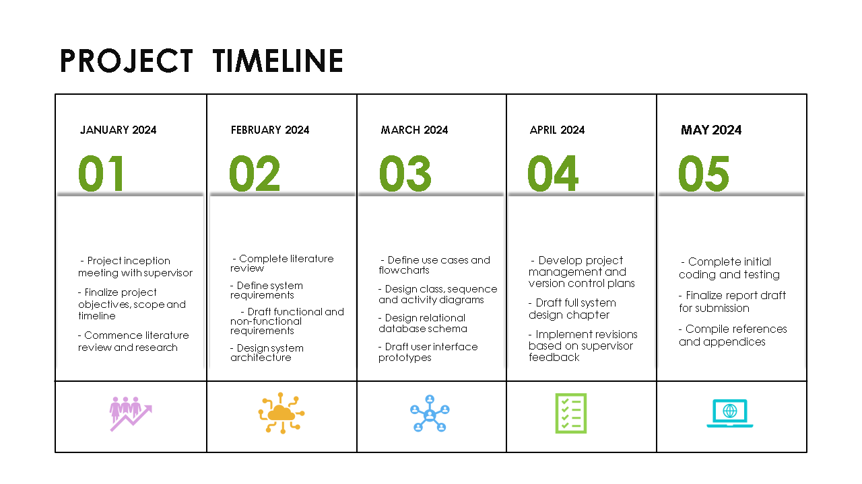

Figure ‎1.5‑1 Project Timeline

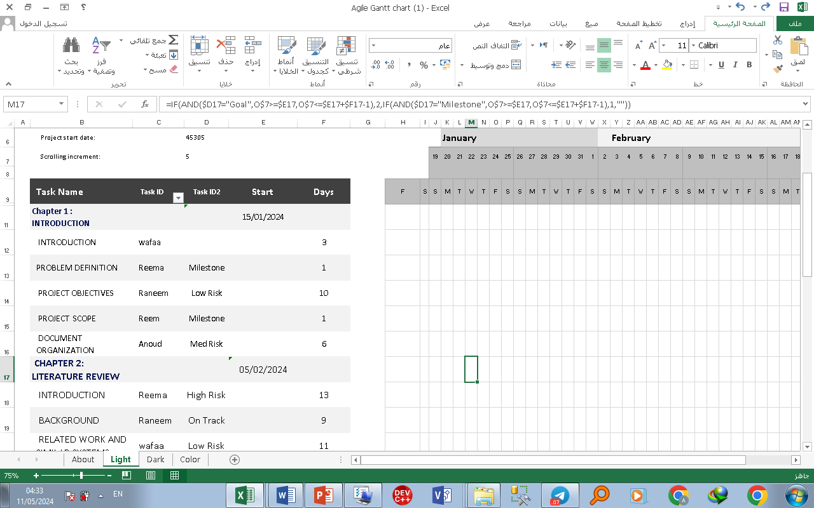

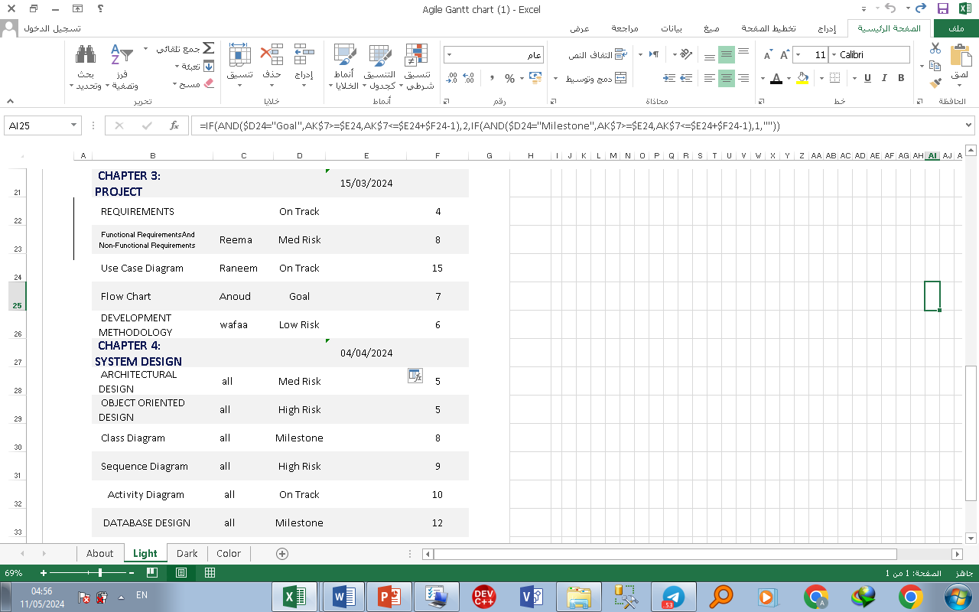

## Document Organization

This project report is composed of six chapters, each crafted to lead the reader through the essential phases of our web-based system development for selling artistic paintings tailored for individuals with special needs.

**Chapter 1** kicks off with the driving forces behind this initiative, aiming to tackle the unique obstacles faced by people with disabilities in showcasing and profiting from their artistic prowess. Here, we define the core problem, outline primary objectives, and provide a broad overview of the project’s scope and timeline.

**Chapter 2**, we dive into the literature review. This section examines the background, related projects, and similar systems within this domain. By analyzing existing initiatives and best practices, we gleaned valuable insights that enriched the design and development of our proposed solution.

**Chapter 3** centers on project requirements and system analysis. We discuss both functional and non-functional requirements, document the overarching system architecture, and describe the development methodology adopted. This chapter also includes use case diagrams and flow charts to illustrate anticipated user interactions and system workflows.

**Chapter 4** is dedicated to detailed system design, encompassing architectural, object-oriented, and database design elements. We present class diagrams, sequence diagrams, activity diagrams, and entity-relationship diagrams to capture the various design components underpinning our web-based platform.

**Chapter 5** outlines the implementation and testing of the web application. This part provides an overview of the technology stack, tools, and programming languages employed, alongside the outcomes of the testing process to ensure the system's functionality and performance.

**Chapter 6** wraps up the report by summarizing key findings, achievements, and the limitations encountered during our project. We also explore potential directions for future work and enhancements to the system, based on our experiences and insights gained throughout the development journey.

By structuring the report in this manner, we aim to offer the reader a comprehensive grasp of our web-based system for selling artistic paintings for individuals with special needs, from initial conceptualization to final implementation and future considerations.

# Chapter 2: Literature Review

## Introduction

The literature review and background study chapter play a crucial role in providing a comprehensive understanding of existing research, theories, and knowledge relevant to our project’s subject matter. This section serves as the foundation for our exploration into the background information necessary for contextualizing the objectives and methodologies of our web-based system for displaying artistic paintings for people with special needs. By delving into foundational concepts, theories, and historical context pertinent to our project, we aim to gain valuable insights that will inform the development and implementation of our innovative platform. Through this literature review, we seek to identify best practices, learn from prior research and similar systems, and leverage existing knowledge to create a robust and effective solution that caters to the unique needs of individuals with disabilities.

## Background

We were exploring opportunities for our graduation project where we could apply our technical skills to positively impact our community. After some research, we discovered how individuals with disabilities often face challenges participating in cultural and creative activities due to physical, financial or social barriers.

We were inspired by initiatives we found that were using digital platforms to increase arts accessibility worldwide. Through web-based galleries, personalized creative tools and virtual communities, people of all abilities were gaining new avenues to experience and share in visual arts. However, we noticed a lack of centralized high-quality offerings tailored for our local population.

This gave us the idea to develop a custom web application targeting this niche. Through our coursework, we had learned best practices for designing intuitive interfaces, structuring dynamic content management systems, and optimizing websites for assistive technologies. We were confident we could leverage these skills to build an engaging online art showcase and marketplace.

Further background reading helped establish a strong understanding of disability issues, art therapy benefits, and entrepreneurship barriers facing socially disadvantaged groups in our society. We aimed to ground our project concept and features firmly based on real user needs and feedback.

As web developer students with a drive for learning through hands-on projects, we saw this as an ideal opportunity to both sharpen our technical skills and contribute value through a meaningful community-focused application.

## Related work and Similar Systems

This section reviews prior research, studies, projects, and similar systems related to the topic of the graduation project will be discussed. Discussion includes the overview of the system, their features, advantages, and disadvantages.

1. **Creative Growth**.



Figure ‎2.3‑11 Creative Growth.

About the project:

This website seeks to display the art of creative growth for people of determination in the state of California. The center aims to provide artists with special needs and provide them with a space full of joy for creativity to flourish. Artistic shots are shown on a regular basis But part of the money for selling paintings goes back to the artist himself, and the other part goes back to the site .

**Goals:**

1. Enabling artists with developmental or mental disabilities to work and become self-reliant

2. Creative Growth seeks artistic communication between artists with disabilities and the broader artistic community, with the aim of increasing understanding and appreciation of their abilities and creativity.

3. Creative Growth works to provide opportunities to display and promote the work of artists with disabilities, with the aim of encouraging interest, purchase and professional support.

**The importance of the project:**

It is a website that seeks to empower and promote artists with disabilities, enhance understanding and appreciation of their artistic abilities, and help them achieve success and independence in the field of art and culture.

1. **Saarhi art**



Figure ‎2.3‑2 2 Saarhi art

It is an online arts website that serves as a global marketplace for contemporary art. Founded in 2006, it offers a platform for artists to showcase and sell their artwork directly to a global audience.

The main objectives of the project:

1. The website aims to provide an interface for artists to display their artwork and communicate with a global audience. Artists can create a gallery of their work and display it professionally and clearly.

2.Saatchi Art offers artists an opportunity to sell their work directly to potential buyers around the world. The site contains thousands of different artworks in various styles and media.

3. The site is interested in encouraging new artists and providing opportunities for emerging artists to display their work and reach a wider audience. It also provides opportunities to mentor emerging artists and develop their careers.

Target groups:

The category is artists with special needs and art community buyers and investors.

1. **ArtPal**

It is an online platform for selling artwork. The platform aims to support artists and enable them to showcase and sell their artwork to a wider audience.

Benefits:

1. ArtPal provides a simple and easy-to-use interface.

2. Artists can reach a global audience through the platform.

3. ArtPal does not impose monthly fees; it only takes a commission when artwork is sold.

**Drawbacks**:

1. ArtPal imposes a commission on sales.

2. There is significant competition on the ArtPal platform.

3. Artists are responsible for managing their own gallery on ArtPal.

**Canvas Art**

It is a Saudi Arabian online store specializing in the sale of art canvases. It is one among several e-commerce stores in the Kingdom of Saudi Arabia that offers a wide variety of art canvases.

Pros:

1. Canvas Art provides a wide selection of art pieces.

2. The store is committed to offering high-quality artwork.

3. It offers flexible delivery options and multiple payment methods.

Cons:

1. The prices of art canvases at Canvas Art can be high.

2. They may charge a commission on sales.

## Summary

This chapter provided our team with valuable insights gathered from reviewing literature in both theoretical and applied works. The key findings from our background study and related projects analysis will help strengthen our system requirements. We have a more informed understanding of user needs and technical considerations to develop a impactful solution catering to people with special needs.

# Chapter 3: Project Requirements and System Analysis

## Introduction

In this chapter, the proposed system is analyzed by a comprehensive discussion of feasibility study and functional and non-functional requirements. Further, it discusses the high-level architecture and the development methodology to be followed to achieve the project.

## Requirements

In This section we summarizes the functional and non-functional requirements of the projects’ deliverables. Depending on the nature of the requirements, they will be categorised in to two categories, functional and non-functional.

### System Hardware and Software

**Hardware**:

We utilized laptops with Core i5 processors, 8GB RAM, and SSD storage to carry out the work.

**Software**:

We installed XAMPP on our machines to test the backend functionalities. We also used Draw.io to document requirements and design workflow diagrams and database schemas.

**Methodology**:

We conducted interviews with potential users to understand their needs and pain points. We also examined similar platforms to identify best practices. We documented all requirements and designed workflow diagrams and database schemas.

**Technology Stack for Minimum Viable Product (MVP):**

**Front-end:**

We plan to use HTML, CSS, and JavaScript for the front-end interfacing.

**Back-end:**

We plan to use PHP with MySQL for the back-end.

**Additional Considerations:**

We expect that various additional plugins and libraries may be required as well.

This report summarizes our initial phase of analysis and planning. In the second phase next term, we will focus on building out the core features and functionalities of the web application to launch a basic version. Ongoing testing and feedback will help us refine and enhance the system over multiple iterations.

### Functional Requirements

1. User Registration and Profile Creation: Users should be able to create an account and provide relevant information such as personal details, contact information, and artistic skills.

2. Artwork Submission: Users should be able to upload their artistic paintings through a user-friendly interface. The system should support various image formats and provide options for adding descriptions and tags to the artwork.

3. Artwork Management: Users should be able to edit, delete, or update the information associated with their submitted artwork.

4. Artwork Display: The system should provide a visually appealing gallery of artwork, allowing users to browse and view paintings submitted by people of determination.

5. Search and Filter: Users should be able to search for specific artwork based on keywords, artist name, or other relevant criteria. The system should also provide filtering options to refine search results.

6. Artist Profile: Each user should have a dedicated profile page that showcases their artwork, bio, and contact information. Users should be able to customize their profile settings.

7. Sales and Transactions: The system should support the sale of artwork, providing users with options to set prices, manage inventory, and handle transactions securely.

8. Notifications: Users should receive notifications about sales, comments, likes, and other activities related to their artwork or profile.

9. Social Interaction: Users should be able to interact with each other through comments, likes, shares, and private messaging.

10. Accessibility Features: The web-based system should be designed with accessibility in mind, ensuring compatibility with assistive technologies and providing features like text-to-speech, high contrast modes, and keyboard navigation.

### Non-Functional Requirements

1. Usability: The system should have an intuitive and user-friendly interface, making it easy for people of determination to navigate, upload artwork, and manage their profiles.

2. Performance: The system should be responsive and provide fast loading times for artwork and profile pages. It should be able to handle a large number of concurrent users without significant performance degradation.

3. Security: The system should implement secure authentication and authorization mechanisms to protect user accounts and sensitive information. It should also have measures in place to prevent unauthorized access, data breaches, and malicious activities.

4. Scalability: The system should be designed to handle a growing number of users and artwork submissions. It should be able to scale its resources, such as storage and processing power, to accommodate increased demand.

5. Compatibility: The web-based system should be compatible with different web browsers, operating systems, and devices to ensure a wide reach and accessibility for users.

6. Data Backup and Recovery: The system should regularly backup user data to prevent loss in case of system failures or data corruption. It should also have a recovery mechanism in place to restore data if needed.

7. Performance Tracking and Analytics: The system should track and analyze user interactions, artwork views, sales, and other relevant metrics to provide insights for system improvements and business decision-making.

8. Multilingual Support: The system should support multiple languages to cater to a diverse user base.

9. Privacy: The system should adhere to privacy regulations and provide users with control over their personal information. It should have a clear privacy policy and obtain consent for data collection and usage.

10. Support and Documentation: The system should have comprehensive documentation and provide reliable customer support to assist users in case of any issues or queries.

## System Design

This section highlights the design of the proposed system by illustrating the application flow via flowchart and use case diagram.

### Use Case Diagram

Use case diagrams visually depict the interactions between system users and the system itself.

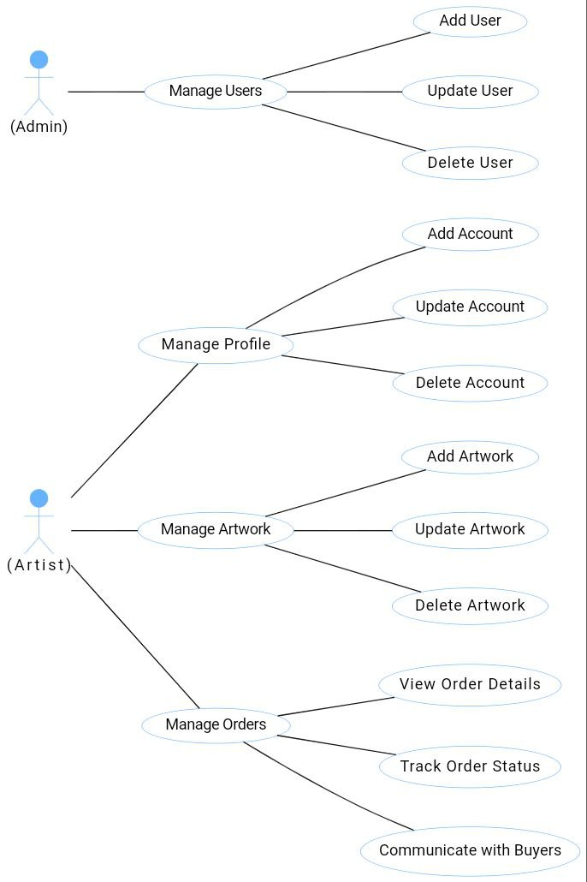

Figure ‎3.3‑1 Use Case Diagram

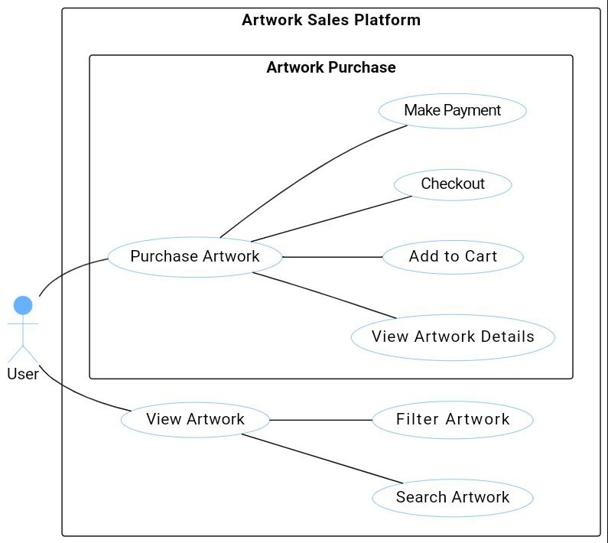

Figure ‎3.3‑2 use case diagram 2

### Flow Chart

#### Homepage Navigation

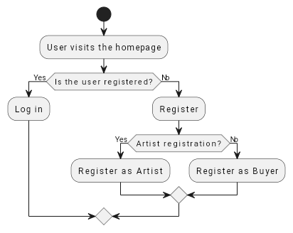

Figure ‎3.3‑3 Flow Chart 1

#### User Registration

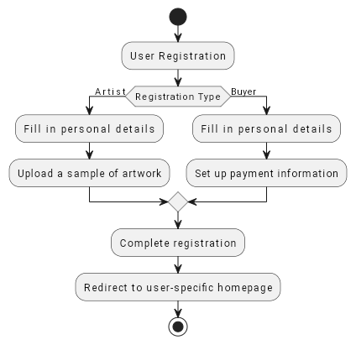

Figure ‎3.3‑4 Flow Chart 2

#### Artist Profile Management

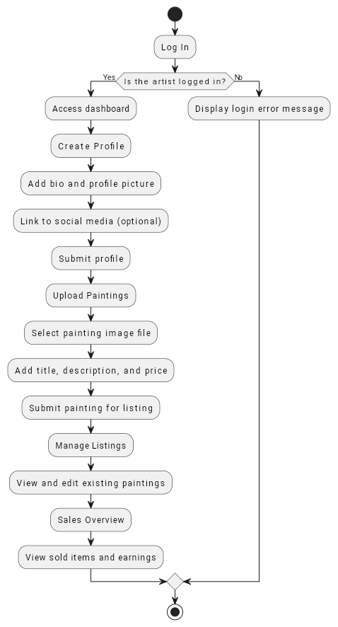

Figure ‎3.3‑5 Flow Chart 3

#### Browsing and Purchasing

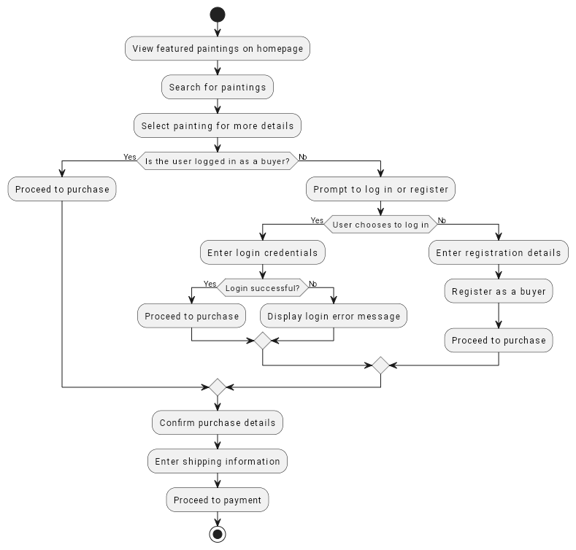

Figure ‎3.3‑6 Flow Chart 4

#### Payment Processing

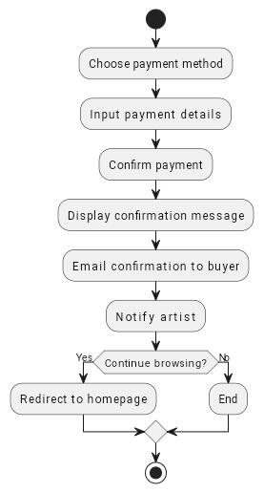

Figure ‎3.3‑7 Flow Chart 5

## Development Methodology

There are different types of methodologies in SDLS.

1. V-model Development Methodology
2. Parallel Development Methodology
3. Iterative Development Methodology
4. Agile Development Methodology
5. System proto-typing Development Methodology
6. Throwaway Prototyping Development Methodology
7. Waterfall Methodology

**Waterfall Methodology**

In this project, we will use this type because this model provides a structured approach through discrete phases that are easy to understand and interpret, provides easily identifiable milestones in the development process, and can be suitable for projects where scope requirements have been defined.

The waterfall methodology in developing the web system for panels for people of determination relies on organized and sequential stages, starting from collecting requirements all the way to periodic maintenance. The main steps include requirements gathering, system design, implementation, testing, deployment, and maintenance. This methodology aims to achieve structure and sequence in development, identify early requirements, improve product quality, ensure clarity and manage risks, which helps in developing a system that effectively meets the needs and expectations of people with special needs.

### Waterfall Methodology

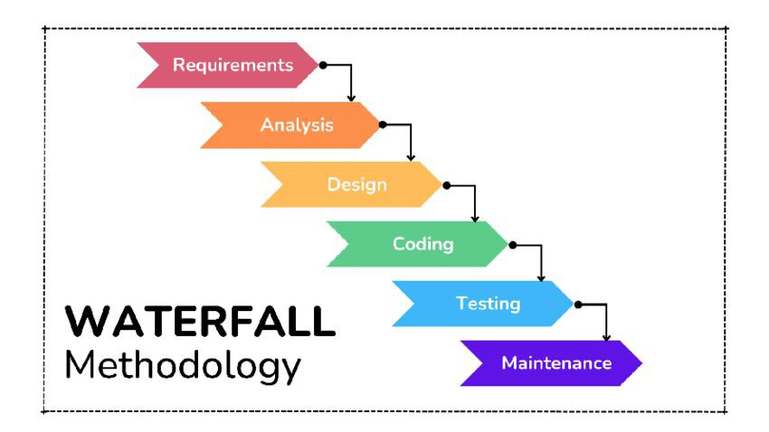

Figure ‎3.4‑1 Waterfall Methodology

* Compare Methodologies:

Table 2 Compare Methodologies

|  |  |  |  |  |  |  |  |
| --- | --- | --- | --- | --- | --- | --- | --- |
| Agile Develop-ment | Throwaway Prototyping | System Proto-typing | Iterative | V-Model | Parallel | Waterfall | Ability to develop systems |
| Excellent | Excellent | Excellent | Good | Poor | Poor | Poor | With unclear user requirement |
| Poor | Excellent | Poor | Good | Poor | Poor | Poor | With unfamiliar technology |
| Poor | Excellent | Poor | Good | Good | Good | Good | That are complex |
| Good | Excellent | Poor | Good | Excellent | Good | Good | That are reliable |
| Excellent | Good | Excellent | Excellent | Poor | Good | Poor | With a short time schedule |
| Good | Good | Excellent | Excellent | Poor | Poor | Poor | With schedule visibility |

## Summary

The chapter concludes with a summary of the project requirements and system analysis, encapsulating key insights and decisions that inform the subsequent phases of system development.

# Chapter 4: System Design

## Introduction

This chapter presents the system design considering the main dimensions of our proposed system. Further, it discusses the various aspects of system design, including architectural, object-oriented, Database design, and user interface design.

## Architectural design

The proposed system is designed with a distributed architecture featuring three primary components: a web application, a database, and a payment gateway. The web application serves as the user interface, allowing artists to create profiles, showcase their artworks, and buyers to browse and purchase. The database stores all relevant data, including artwork details, user information, and transaction records. The payment gateway ensures secure and efficient payment processing. The system adheres to accessibility guidelines to ensure ease of use for users with disabilities.

## Object Oriented Design

### Class Diagram

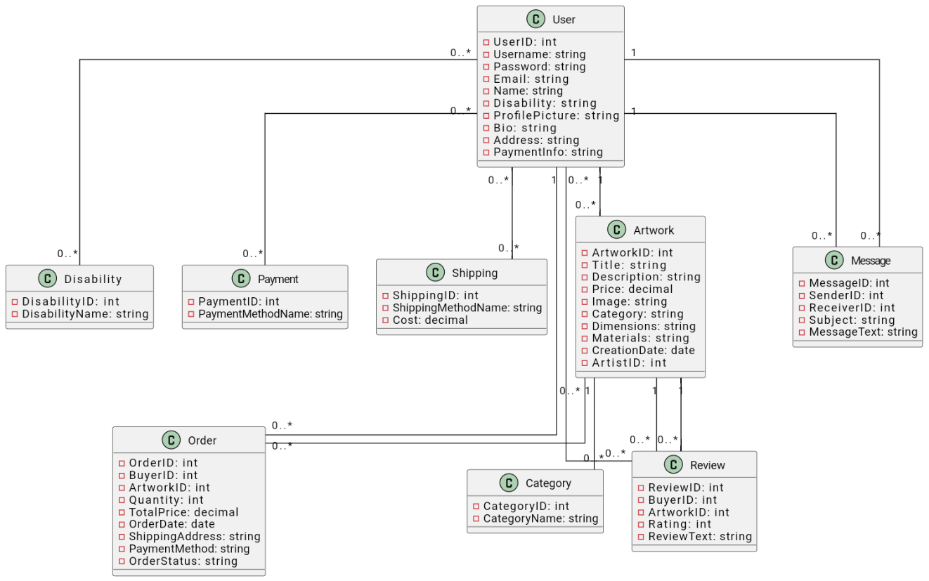

Figure ‎4.3‑1 Class Diagram

### Sequence Diagram

#### Sequence Diagram 1: User Registration and Login

. 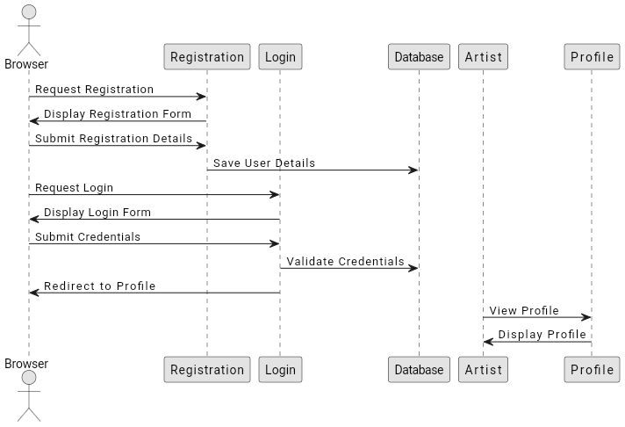

Figure ‎4.3‑2 Sequence Diagram 1

#### Sequence Diagram 2: Artwork Upload and Search

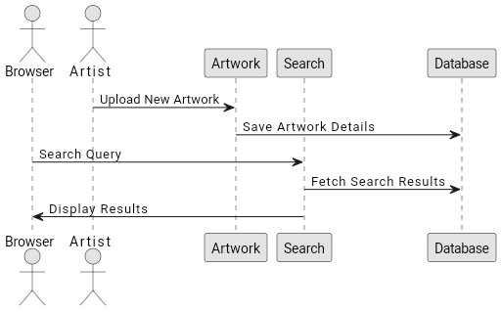

Figure ‎4.3‑3 Sequence Diagram 2

#### Sequence Diagram 3: Payment and Notifications

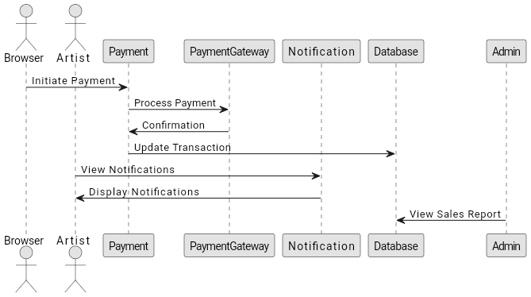

Figure ‎4.3‑4 Sequence Diagram 3

### Activity Diagram

Activity diagrams represent the workflow or procedural logic of a system, capturing the sequence of activities and decision points involved in a process.

#### Activity Diagram 1: Artist Activities

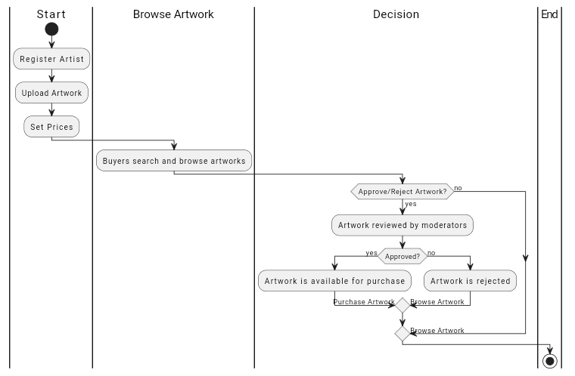

Figure ‎4.3‑5 Activity Diagram 1: Artist Activities

#### Activity Diagram 2: Buyer and System Activities

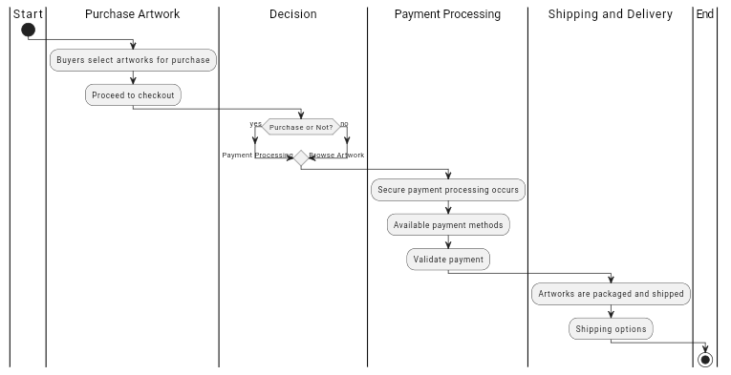

Figure ‎4.3‑6 Activity Diagram 2: Buyer and System Activities

## Database Design

This section focuses on the design of the system's database, including the creation of entity-relationship diagrams (ERDs) and schema definitions.

* **USER**

|  |  |  |
| --- | --- | --- |
| Attribute | Type | Rule |
| UserID | **string** | **PK** |
| FirstName | **string** |  |
| LastName | **string** |  |
| Email | **string** |  |
| Password | **string** |  |
| PhoneNumber | **string** |  |
| Address | **string** |  |
| DateOfBirth | **Date** |  |
| Gender | **string** |  |
| RegistrationDate | **Date** |  |
| User_nicename | **string** |  |
| User_status | **int** |  |
| User_activation_key | **string** |  |

Table ‎4.4‑1 User Database Table

* **ACCOUNT**

|  |  |  |
| --- | --- | --- |
| Attribute | Type | Rule |
| AccountID | string | PK |
| Username | string |  |
| Password | string |  |
| Email | string |  |

Table ‎4.4‑2 Account Database Table

* **ADMIN**

|  |  |  |
| --- | --- | --- |
| Attribute | Type | Rule |
| AdminID | int | PK |
| Name | varchar |  |
| Username | varchar |  |
| Password | varchar |  |
| Email | varchar |  |
| Display_name | varchar |  |

Table ‎4.4‑3 Admin Database Table

* **ARTWORK**

|  |  |  |
| --- | --- | --- |
| Attribute | Type | Rule |
| ArtworkID | string | PK |
| Title | **varchar** |  |
| Description | varchar |  |
| Price | **decimal** |  |
| Image | varchar |  |
| CreationDate | **Date** |  |
| Availability | varchar |  |
| UserID | **string** | **FK** |

Table ‎4.4‑4 Artwork Database Table

* **LINE_ARTWORK**

|  |  |  |
| --- | --- | --- |
| Attribute | Type | Rule |
| LineID | int | PK |
| ArtworkID | string | FK |
| Quantity | int |  |
| Price | decimal |  |

Table ‎4.4‑5 Line Artwork Database Table

* **ORDER**

|  |  |  |
| --- | --- | --- |
| Attribute | Type | Rule |
| OrderID | int | PK |
| Status | varchar |  |
| Currency | varchar |  |
| Tax_amount | decimal |  |
| Total_amount | decimal |  |
| CustomerID | string | FK |
| Billing_email | varchar |  |
| Date_created | datetime |  |
| Date_updated | datetime |  |

Table ‎4.4‑6 Order Database Table

* **PAYMENT**

|  |  |  |
| --- | --- | --- |
| Attribute | Type | Rule |
| PaymentID | int | PK |
| Credit_card_num | varchar |  |
| FormID | bigint |  |
| Status | varchar |  |
| Subtotal_amount | decimal |  |
| Discount_amount | decimal |  |
| Total_amount | decimal |  |
| OrderID | int | FK |
| Payment_method | varchar |  |
| Transaction_id | string | PK |

Table ‎4.4‑7 Payment Database Table

* **SHIPPING_INFORMATION**

|  |  |  |
| --- | --- | --- |
| Attribute | Type | Rule |
| ShippingID | int | PK |
| City_name | varchar |  |
| Street_address | varchar |  |
| Total_price | decimal |  |
| OrderID | int | FK |
| Expected_delivery_time | datetime |  |

Table ‎4.4‑8 Shipping information Table

* **REVIEW**

|  |  |  |
| --- | --- | --- |
| Attribute | Type | Rule |
| ReviewID | string | PK |
| Rating | int |  |
| Comment | varchar |  |
| ReviewDate | Date |  |
| ArtworkID | string | FK |
| UserID | string | FK |

Table ‎4.4‑9 Review Database Table

* **CATEGORY**

|  |  |  |
| --- | --- | --- |
| Attribute | Type | Rule |
| CategoryID | string | PK |
| CategoryName | varchar |  |

Table ‎4.4‑10 Category Database Table

* **DISABILITY**

|  |  |  |
| --- | --- | --- |
| Attribute | Type | Rule |
| DisabilityID | string | PK |
| DisabilityName | varchar |  |

Table ‎4.4‑11 Disability Database Table

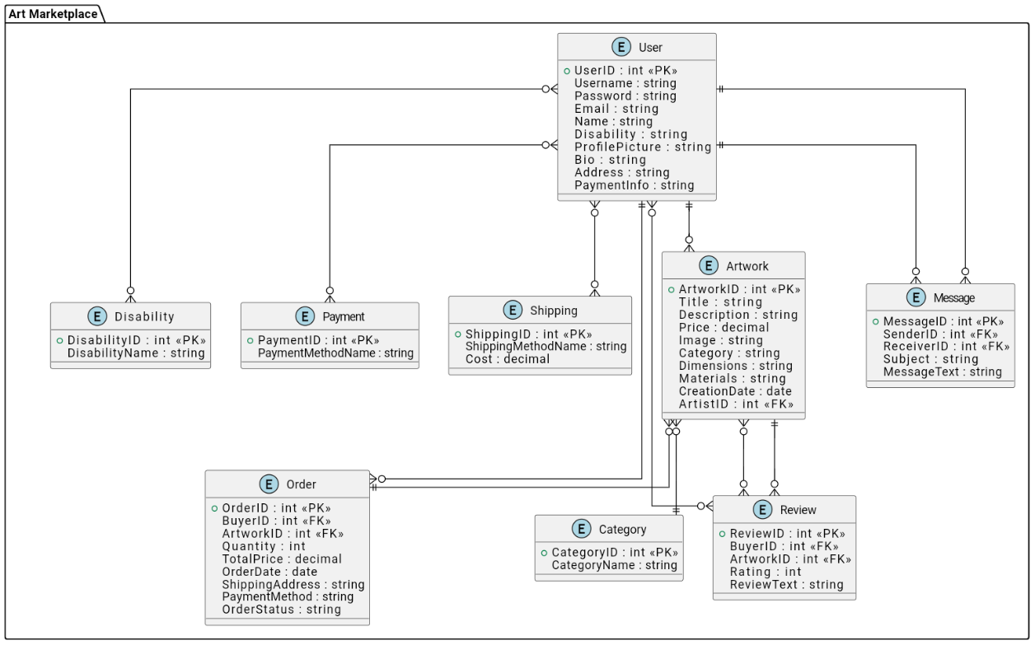

Figure ‎4.4‑1 Entity-relationship diagrams (ERDs)

## User Interface Design

The project details the design of the user interface, encompassing the layout, navigation, and visual elements of the system.

## Summary

In summary, this chapter outlines the key components of our system design, emphasizing the architectural layout, object-oriented principles, database structure, and user interface considerations. Each aspect has been carefully crafted to create a cohesive and functional platform that empowers individuals with disabilities to showcase their artistic talents effectively. Through this design framework, we are poised to create a meaningful impact within our community.

# Chapter 5: Implementation and Results

## Introduction

This chapter provides an overview of the technology infrastructure and tools that underpinned the development, implementation, and testing of our web-based system for selling artistic paintings. We detail the methodologies employed, the tools selected, and the results of our testing processes. This systematic approach ensured that the platform not only met technical specifications but also served its purpose effectively in empowering artists with special needs.

## Tools and Technologies used

#### 5.2 Tools and Technologies Used

Our project utilized a carefully chosen set of tools and technologies to ensure a robust and user-friendly platform:

* **Programming Languages**:
  + **HTML, CSS, JavaScript**: These languages formed the backbone of our frontend development, enabling us to create a responsive and engaging user interface tailored for our target audience.
  + **PHP**: This server-side scripting language was instrumental in managing dynamic content, processing user requests, and facilitating communication between the frontend and the database.
  + **MySQL**: We employed this relational database management system to store and retrieve data efficiently, ensuring that user profiles, artwork submissions, and transactions were securely managed.
* **Frameworks and Libraries**:
  + **Bootstrap**: This framework was utilized to enhance the visual appeal and responsiveness of our web application, allowing users to navigate seamlessly on various devices.
  + **jQuery**: We integrated this library to simplify DOM manipulation and streamline the implementation of interactive features.
* **Development Tools**:
  + **XAMPP**: This software package provided a local server environment, enabling us to test our application before deployment.
  + **Visual Studio Code**: Our primary code editor, equipped with useful extensions, facilitated efficient coding, debugging, and version control.

## Implementation

The implementation of the project.

## Testing Case

Snapshots of a testing case.

## Results

# Chapter 6: Conclusion and Future Work

## Conclusion

Embarking on the creation of our online platform for selling artistic paintings crafted by individuals with special needs, we've triumphantly met our primary objectives. This platform provides a dedicated space for artists with disabilities to showcase their creations, generate income, and foster social inclusion. By harnessing modern web technologies, we've developed an accessible, user-friendly marketplace tailored to the unique needs of this underserved community. Essential features such as effortless artwork submission, personalized artist profiles, and secure payment processing effectively tackle the barriers artists with disabilities face in traditional sales channels.

## Limitations

The platform encountered a variety of constraints:

1. **Limited Integration**: Functioning autonomously, the system lacks connections to external platforms or galleries, thus restricting artist audience reach.

2. **Scalability Challenges**: The existing infrastructure may falter under a surge of new users, potentially degrading performance.

3**. Basic Analytics:** Offering only rudimentary reporting, the platform limits insights into sales trends and user behaviors.

4**. Language Accessibility**: With availability restricted to a single local language, non-native speakers face accessibility barriers.

## Future Work

Prospective enhancements encompass:

1**. Integration with External Platforms**: Establishing links with other art or social service platforms to amplify exposure and sales opportunities.

2. **Enhanced Scalability**: Transitioning to scalable cloud hosting solutions to ensure performance stability amidst user growth.

3. **Advanced Analytics**: Introducing features for comprehensive sales and engagement tracking to guide strategic decisions.

4. Multilingual Support: Expanding language offerings to broaden accessibility and market reach.

**References**

[1] P. Likarish, E. Jung, D. Dunbar, T. E. Hansen, and J. P. Hourcade, "B-APT: Bayesian Anti-Phishing Toolbar," 2008 IEEE International Conference on Communications, 2008, pp. 1745-1749, doi: 10.1109/ICC.2008.335.

[2] Phishing website dataset available at https://www.kaggle.com/

[3] http://s3.amazonaws.com/alexa-static/top-1m.csv.zip

[4] . <https://github.com/mitchellkrogza/Phishing.Database/blob/master/phishing-domains-ACTIVE.txt>